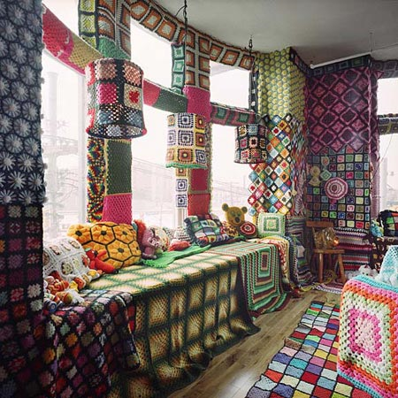
http://blog.timesunion.com/fiberarts/files/2009/07/crochet-room1.jpg

